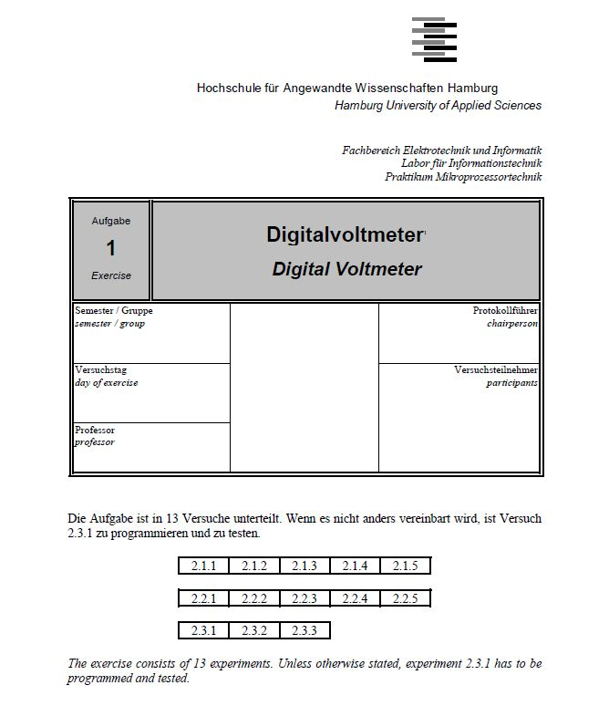

- Introduction

In this lab, we will develop a program that, in effect, works as a digital voltmeter. There are in total 2 assignments in this lab: an external digital-to-analogue converter and analogue-to-digital converter. A external D/A converter will receive the input in binary codes and will output it in analogue form, while the A/D converter do it vice-versa.

Figure 1 shows the PC system for development and the H8S/2357 board.
− The components of the digital voltmeter have to be wired with the input/output board.
− Use editor, compiler or assembler, and linker of the PC system for developing the control software for the analog-to digital conversion programs.
− Then transfer the control software to the H8S/2357 board for test.

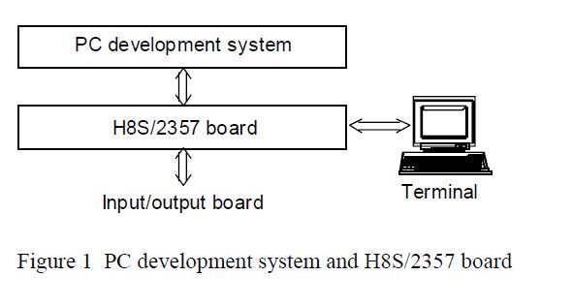

- Experiment 1

  - Lab task
In this task, our goal is to create a C-program to operate an external digital-to-analogue converter, using the staircase method. Staircase method involves using a counter to increase an arbitrary voltage, or make a "staircase" until it reaches the value of the input voltage, and then stop to display the value.

2.2 Set up
In the setup, we required the following equipment:

- A computer with IAR C-project and the corresponding debugger
- Microcontroller Hitachi H8S/2357F
- I/O Controller Board
- An External D/A Converter (Comparator included)
- 7-segment display
- Stop button

In the experiment, we will being using the IAR C-project and its debugger to write a c-program, which will be processed by the microcontroller, with I/O controller board as input and output port. The board will be connected to the external D/A Converter and the stop button and send the result out through the 7-segment display.

The schematic of this setup can be found in Figure 2.

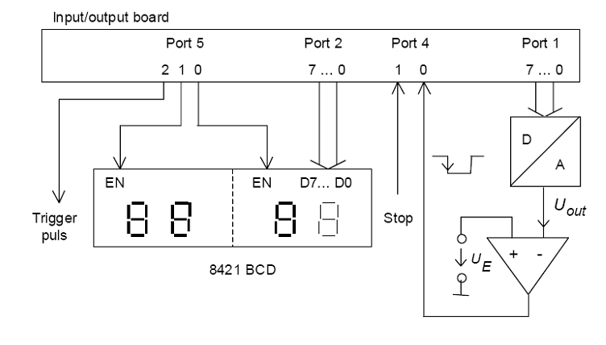

Figure 2: Measurement setup

The transfer characteristics of this setup can be found in Figure 3.
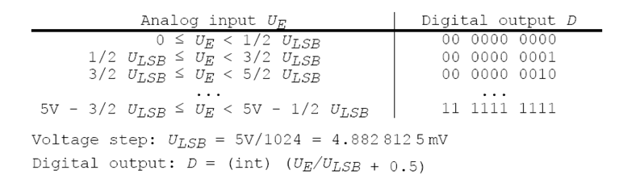

Figure 3: Transfer Characteristics

  - Observation

Firstly, we need to understand the relationship between the I/O ports and the devices. In this case, Port D shall be representing the value of the counter needed to make the "staircase", thus in the program PortD shall be set to output. Next, Port J shall be representing the values needed to show on the display, thus Port J shall be set to output. Next, PortG will be taking the value from the comparator, which will be used to determine when to stop the staircase, thus Port G will be set to input. PortE will be used to control the 7-segment display, thus PortE will be set as output.

  - Completed codes with comments

#include "mpp1.h"
// the header file for the micro controller is included.

// this is a waiting loop.
// parameter x denotes the time taken for the loop to end.
// unit of x is in mS.
void waiting(int x){
int i;
for(i=0;i<x;i++);
}

// this is a display function
// parameter x is displayed on the 7-segment display.
void display(long x){
unsigned char d0, d1, d2, d3;
// assign variable for each digit that will be displayed

d0 = (unsigned char) ((x/1000)%10);
d1 = (unsigned char) ((x/100)%10);
d2 = (unsigned char) ((x/10)%10);
d3 = (unsigned char) (x%10);
// put the digit to its corresponding variable

P5DR = 0x01; // change last two digit
P2DR = (d1<<4) | d0; // display digit 1 and digit 0
P5DR = 0x02; // change first two digit
P2DR = (d3<<4) | d2; // display digit 3 and digit 2
}
// start of the main program
void main(void){
P1DDR = 0xFF; // allocates Port1[0] to Port1[7] as output
P2DDR = 0xFF; // allocates Port2[0] to Port2[7] as output
PORT4 = 0x00; // allocates Port4[0] and PORT4[1] as input
P5DDR = 0xFF; // allocates Port5[0] to Port5[2] as output

unsigned char count; // variable for counting
long value; // variable to display

// this is an infinite loop of while(1)
// this means the program runs until manually terminated
while(1){

// this segment is for the counter process
// counter uses do-while loop as explained.
count = 0; // reset the counter
// counter process continued
do{
P1DR = count; // output current count to Port1
waiting(30); // wait for result
count++; // move on to next count
if(count>255){ break; } //terminates if value exceed
}while((PORT4 & 0x01)== 0x01);

// at this point, the current count is the one we have to // display

value = count*19531; // convert count to its corresponding voltage
display(value); // show this on the display
}

- Experiment 2

  - In this task, our goal is to create a C-program to operate an external digital-to-analogue converter

  - Set up
In the setup, we required the following equipment:

- A computer with IAR C-project and the corresponding debugger
- Microcontroller Hitachi H8S/2357F
- I/O Controller Board
- 7-segment display
- Stop button

In the experiment, we will being using the IAR C-project and its debugger to write a c-program, which will be processed by the microcontroller, with I/O controller board as input and output port. The board will be connected to the stop button and send the result out through the 7-segment display.

The schematic of this setup can be found in Figure 4.

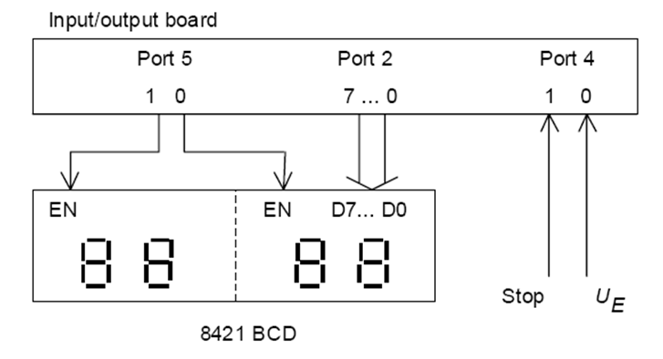

Figure 4: Measurement setup
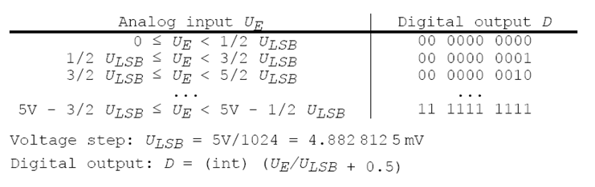
Figure 5: Transfer characteristics

  - Observation

Firstly, we need to understand the relationship between the I/O ports and the devices. In this case, Port2 shall be representing the values needed to show on the display, thus Port2 shall be set to output. Next, Port4 will be taking the value from the input voltage and stop button, thus Port4 will be set to input. Port5 will be used to control the 7-segment display, thus Port5 will be set as output.

  - Completed codes with comments

/********************************
Practical-assignment 3
DIGITAL VOLTMETER

Date: 30.11.2010
Version 1.0
****************************/

#include "stdio.h"
#include "mpp1.h"

#define ULSB 0.0048828125 // Voltage-step U = 5.0V/1024
#define STOPBUTTON (PORT4 & 0x02) // Stop button
#define OFFSET 0.058
// Delay
void waitloop (unsigned long time) {
unsigned long j;
for (j=0; j<time ; j++)
;
}

int main (void)
{
int value=0;
double number=0;
unsigned char bcd[4]; // bcd[3]= 10^0 bcd[2]=10^-1 bcd[1]=10^-2 bcd[0]=10^-3 base

P1DDR=0xFF; // Port 1 to Output 0b 1111 1111
P2DDR=0xFF; // Port 2 to Output 0b 1111 1111
P5DDR=0x0F; // Port 5 to Output 0b 0000 1111

P1DR=0x00; // P1DR set to zero
P2DR=0x00; // P1DR set to zero
P5DR=0x0F; // BCD display:"0"-cases issued 0b 00001111
P5DR=0x03; // Enable to take data 0b 0000 0011
waitloop(6);
P5DR=0x00; // Enable off
waitloop(6);

while (!STOPBUTTON) {

P5DR+=0x04; // set Trigger pulse
waitloop(6);

/* Read the values from Port 1 and Port 4 (1) */
while ((PORT4 & 0x01)&&(P1DR<1023)) {
P1DR ++;
value=P1DR;
waitloop(6);
} // End

/* Load converted values*/
number=(value*ULSB-OFFSET);

P5DR-=0x04; // cancel trigger pulse

/*calculation of output numbers */
bcd[3]=(unsigned char)number-((unsigned char)(number/10))*10;
number-=bcd[3];

bcd[2]=(unsigned char)(number*10)-((unsigned char)(number/10))*10;
number*=10;
number-=bcd[2];

bcd[1]=(unsigned char)(number*10)-((unsigned char)(number/10))*10;
number*=10;
number-=bcd[1];

bcd[0]=(unsigned char)(number*10)-((unsigned char)(number/10))*10;
number*=10;
number-=bcd[0];

/*calculation example
number=2,569
number=number-bcd[3]=2,569-2=0,569
Second digit position :
number*10=0,569*10=5,69 / 5,69/10=BCD output to the display */

P5DR=0x02; // Enable 1 for the left side
waitloop(6);
P2DR=(bcd[3]<<4)+bcd[2]; // write Values on the left side
waitloop(6);
P5DR=0x00; // Enable off again
waitloop(6);

P5DR=0x01; // Enable 0 for the right side
waitloop(6);
P2DR=(bcd[1]<<4)+bcd[0]; // write values on the right side
waitloop(6);
P5DR=0x00;// Enable off
waitloop(6);
/* End of task */

P1DR=0x00; // clear Port 1 output

waitloop(800);
}

/* If stop is pressed */
P2DR=0x00; // P2DR set to Zero
P5DR=0x0F; // BCD display : "0" cases issued 0b00001111
P5DR=0x03; // Enable to take data 0b0000 0011
waitloop(6);
P5DR=0x00; // Enable off
waitloop(6);

return 0;
}

- Conclusion

Result and Evaluation

The result of our program fulfills the need for this task. The corresponding value is shown on the 7-segment display.

One thing we note is that by using internal as oppose to external converter, this does not require a counter and thus, making it less prone to error due to delays.

This experiment allows us to see how an A/D converter works.
It takes an input voltage (analog value) and converts it into a digital value. In order to write the code we need the transfer characteristics of the A/D converter. We have to write a code that allows to take an input analog data and then convert it into a set of binary digits. We had to use different means of calculation in our source code.
The end result must then be displayed onto the 7 segments displays. In this experiment we are only displaying 4 digits.
We could display voltage from 0 to 5V.

